CS 340 README File

CS 340 Project Two: Grazioso Salvare Dashboard

Project Overview
For this project, I developed an interactive dashboard for Grazioso Salvare, a company that trains rescue dogs for search-and-rescue operations. The purpose of the dashboard is to help users identify dogs from the Austin Animal Center database that may be good candidates for specific rescue training programs.
The dashboard connects to a MongoDB database through the CRUD module that I created in Project One. Users can filter animal records based on different rescue categories and view the results through an interactive data table, a geolocation map, and a chart visualization.
Dashboard Functionality
The dashboard was designed to make it easy for users to search and analyze animal shelter data. Several interactive features were added so that the information displayed updates automatically when a rescue category is selected.
The dashboard includes:
- Grazioso Salvare logo
- Developer identifier (Anjali Tamang)
- Interactive rescue type filters
- Interactive data table
- Geolocation map
- Chart visualization
- Reset option
Initial Dashboard Display and Water Rescue Filter
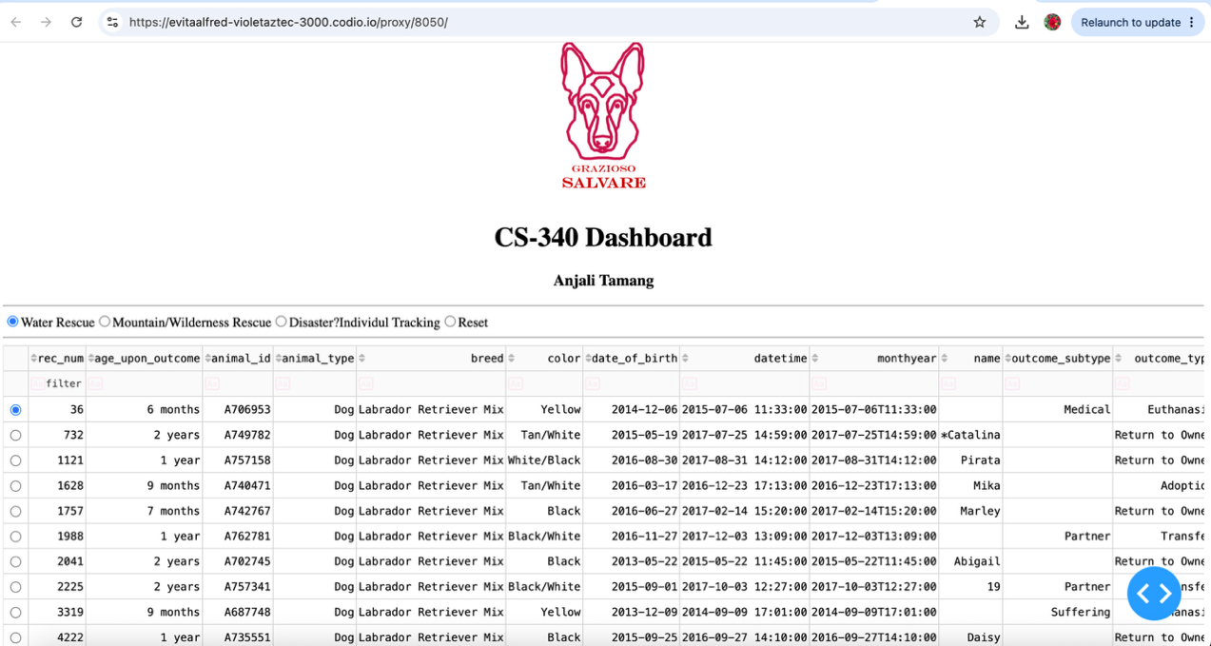
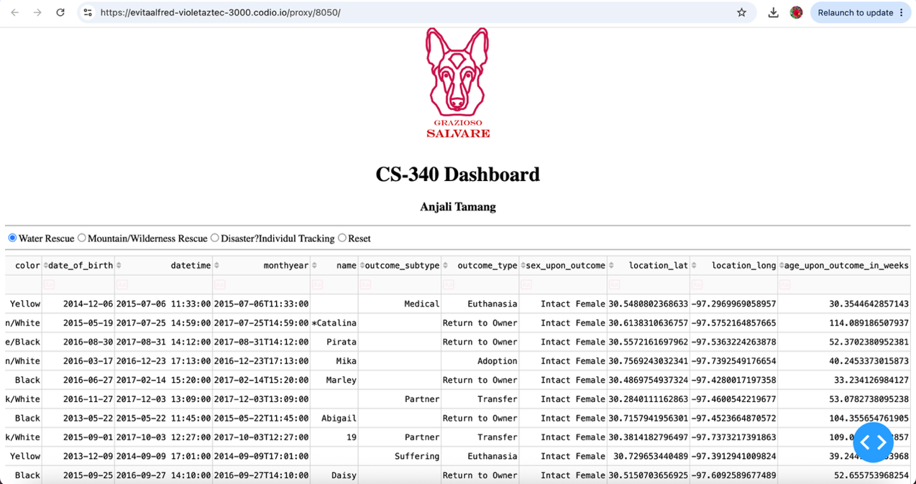
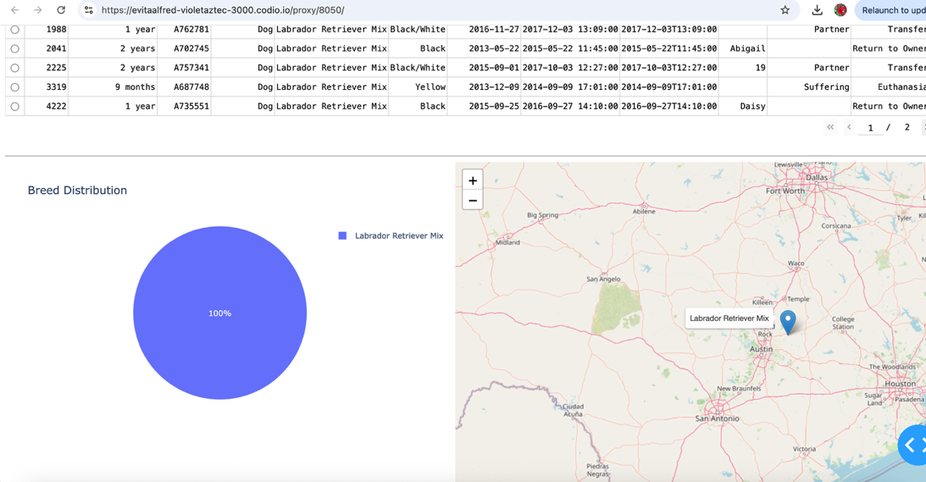

Mountain or Wilderness Rescue Filter
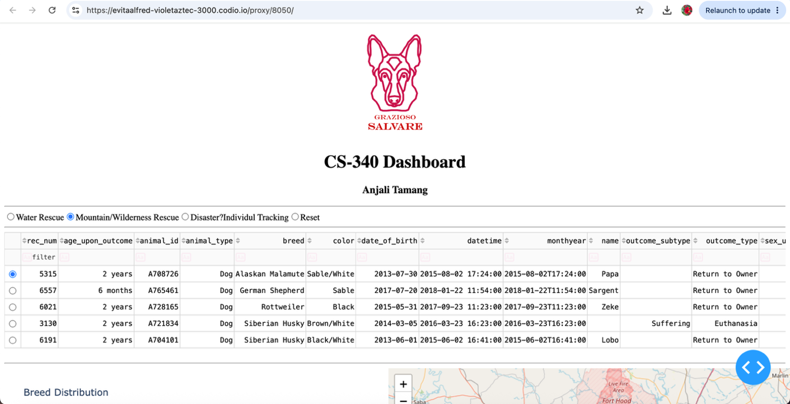
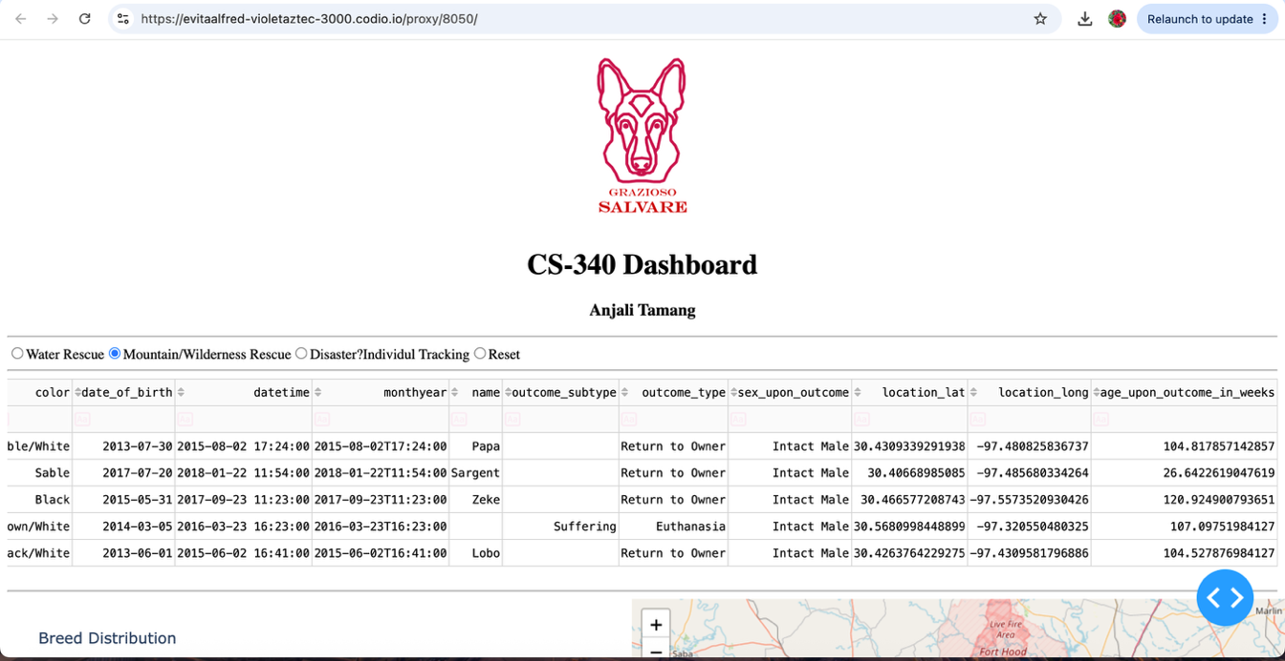

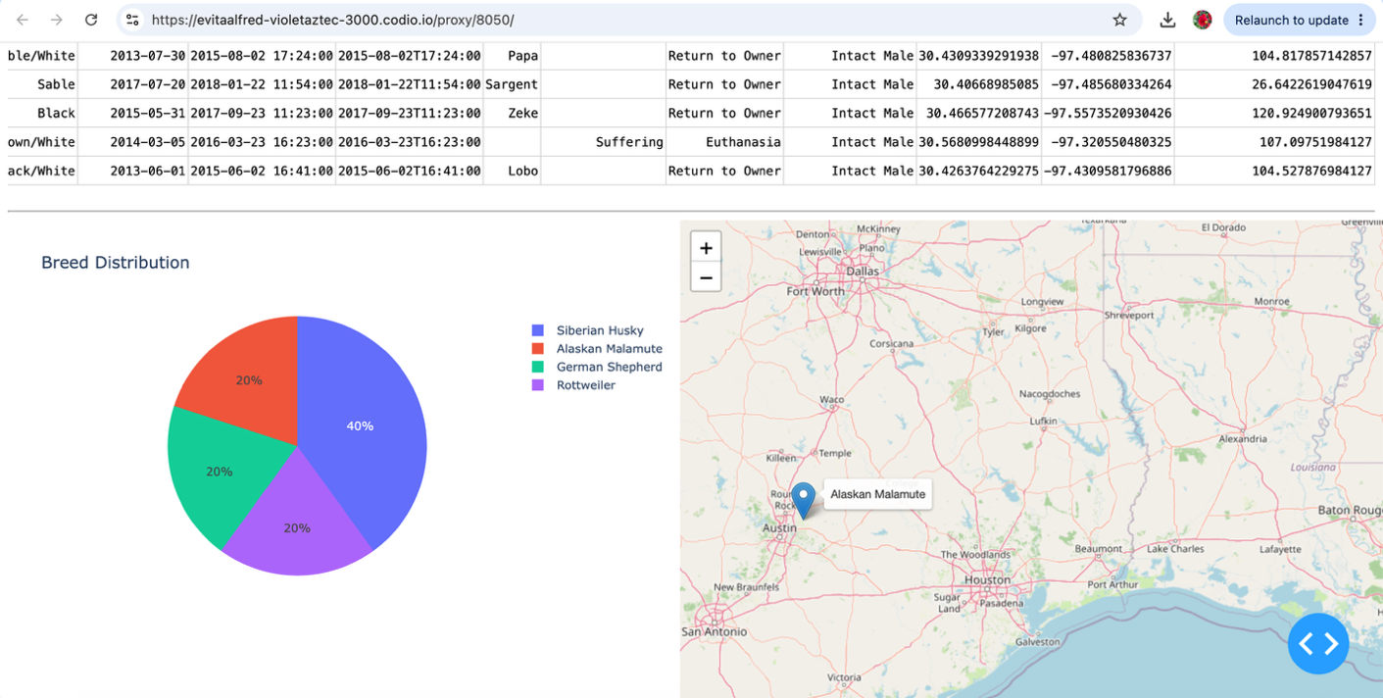

Disaster or Individual Tracking Filter

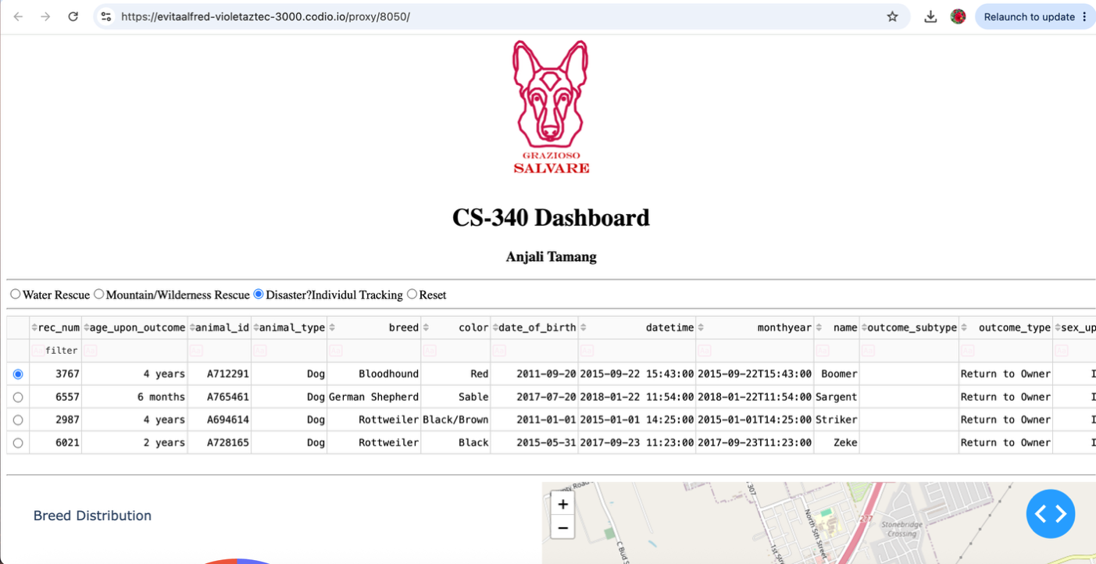
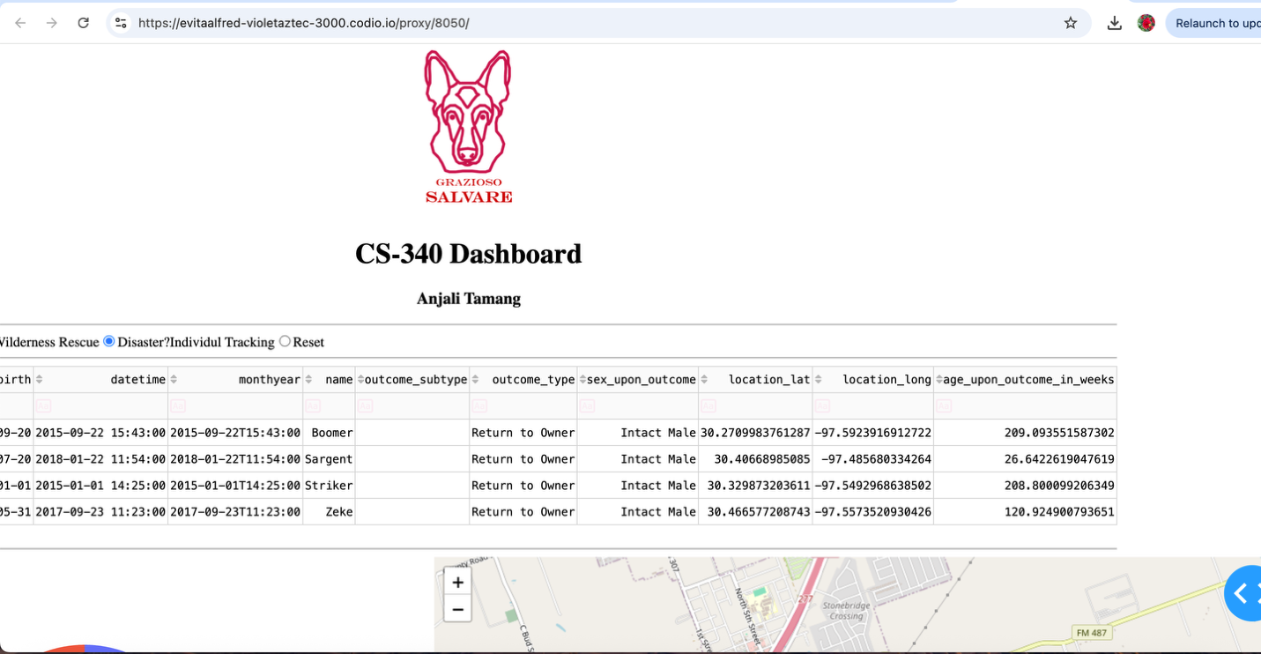
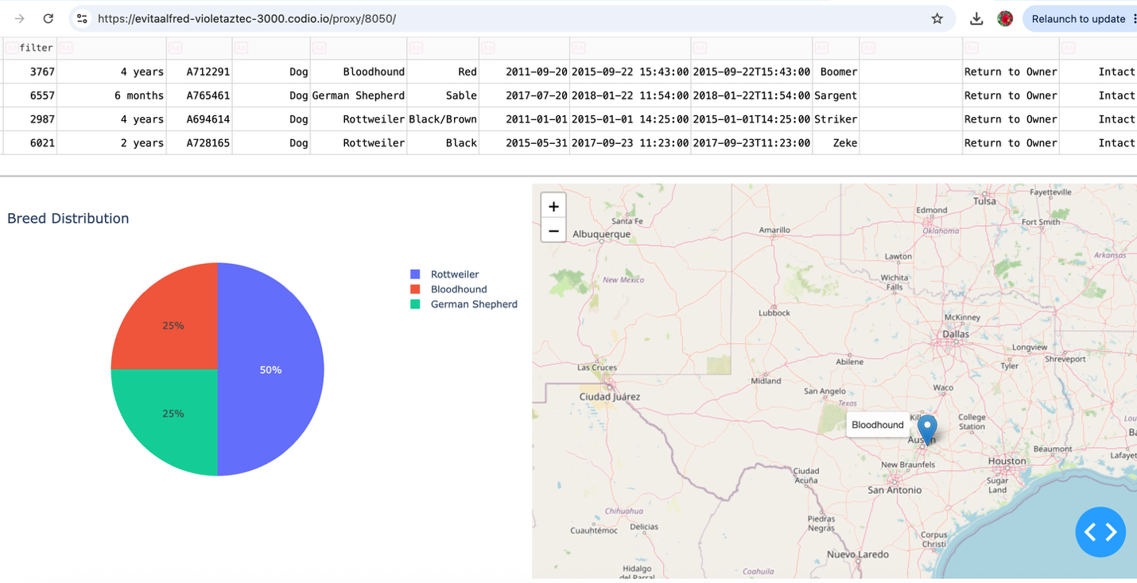

Reset Filter
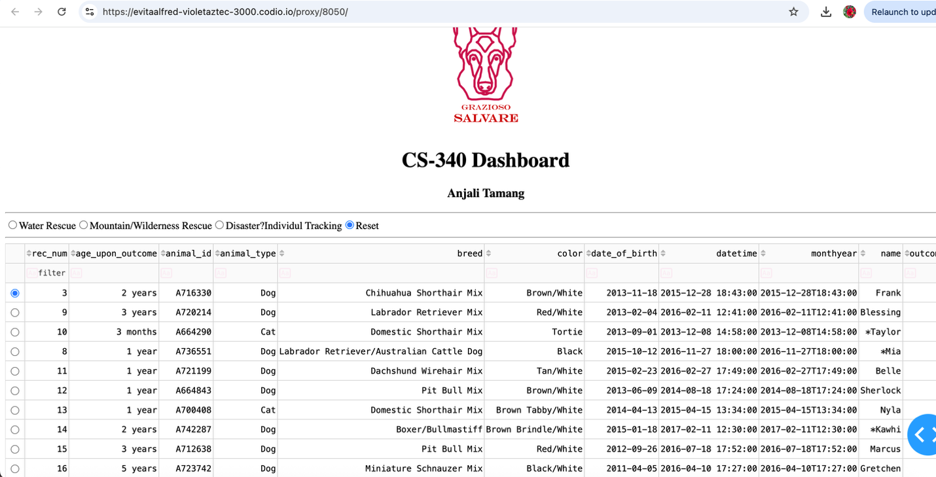
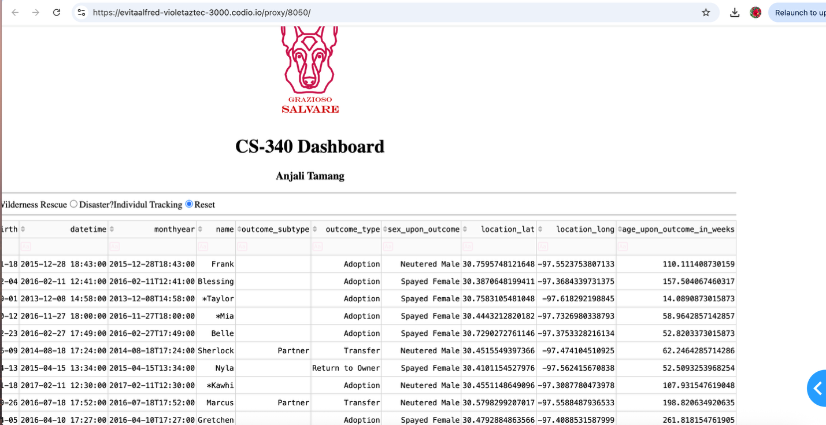
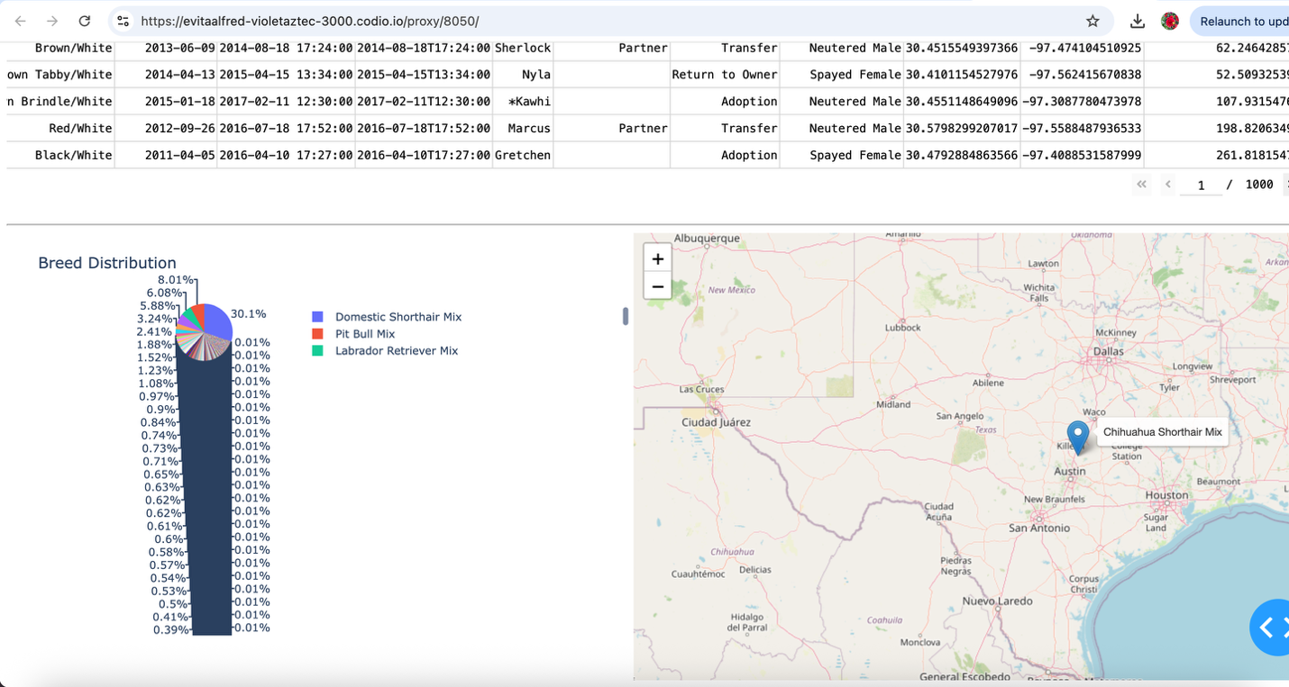

MongoDB
MongoDB was used to store the Austin Animal Center data. I selected MongoDB because it handles large collections of data efficiently and works well with Python. MongoDB stores information as documents, which makes it flexible and easy to query when filtering records for the dashboard.

PyMongo
PyMongo was used to connect Python to MongoDB. This library allowed me to perform database operations and retrieve the records needed by the dashboard.

Python
Python was used to create both the CRUD module and the dashboard application. The CRUD module acts as the connection between the dashboard and the database.

Dash Framework
The dashboard was built using Dash. Dash made it possible to create an interactive web application using Python. Through Dash callbacks, the table, map, and chart automatically update whenever a user selects a different rescue category.

Additional Libraries
Other libraries I used in this project include:
- Pandas for data processing
- Plotly Express for chart creation
- Dash DataTable for displaying records
- Dash Leaflet for mapping animal locations

Steps I took to Complete the Project
To complete this project, I first connected the dashboard to the MongoDB database using the CRUD module developed in Project One. After establishing the connection, I created a data table that displayed records from the Austin Animal Center dataset.
Next, I developed the filtering options for the different rescue categories. Database queries were created so that each filter would return the correct records. After the filters were working, I added a geolocation map and a chart visualization that respond to user selections.
Finally, I tested each dashboard feature to ensure the filters, table, map, and chart updated correctly. Screenshots were taken to document the successful operation of the dashboard.
Challenges Encountered
One challenge I encountered was connecting the dashboard components to the MongoDB data. At times, the data table did not update correctly because of callback configuration issues. I resolved this problem by carefully checking the callback inputs and outputs.
Another challenge involved the MongoDB "_id" field. This field caused formatting issues when displaying records in the data table. I corrected the issue by removing the "_id" column before displaying the data.
I also experienced difficulties with the geolocation map during development. After reviewing the coordinate data and callback logic, I was able to display the correct location information on the map.
Working through these issues helped me better understand how Dash components interact with MongoDB data and how callbacks control updates within the dashboard.

Resources
- MongoDB Documentation
- Dash Documentation
- Plotly Documentation
- PyMongo Documentation
- Dash Leaflet Documentation
- CS 340 course materials and module resources

Conclusion
This project allowed me to combine MongoDB, Python, PyMongo, and Dash to create a functional dashboard application. The completed dashboard provides an easy way for users to filter animal records, view location information, and identify dogs that may be suitable for rescue training programs. Through this project, I gained additional experience working with databases, web applications, and interactive data visualizations.

Contact

Anjali Tamang

